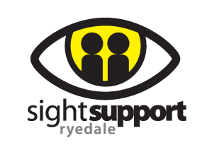
Gift Aid Declaration

To: Sight Support Ryedale
Please treat all gifts of money that I make today, in the future and those that I have made in the past 4 years as Gift Aid donations.
I confirm I have paid, or will pay, an amount of Income Tax and/or Capital
Gains Tax for each tax year (6 April to 5 April) that is at least equal to
the amount of tax that all the charities or Community Amateur Sports
Clubs (CASCs) that I donate to will reclaim on my gifts for that tax year

Donor’s details
Title…………Initials………………………Surname…………………………………………
Home Address…………………………………………………………………………………..
………………………………………………………………………………………………………..
………………………………………………………………………………………………………..
Postcode………………………………….Date………………………………………………

Signature………………………………………………………………………….
I am a UK taxpayer and understand that if I pay less Income Tax and/or Capital Gains Tax than the amount of Gift Aid claimed on all my donations in that tax year it is my responsibility to pay any difference
Please notify Sight Support Ryedale if you:
- Want to cancel this declaration
- change your name or home address
- no longer pay sufficient tax on your income and/or capital gains

If you pay Income Tax at the higher or additional rate and want to receive the additional tax relief due to you, you must include all your Gift Aid donations on your Self-Assessment tax return or ask HM Revenue and Customs to adjust your tax code.

